**Demo: Creating Merge conflict and resolving in GIT local Repository**

**Objective:** To create branch and merge a Git local repository for understanding the fundamentals of repository management and merge conflict control using Git

**Tools required:** Git

**Prerequisites:** We need to have Git installed to proceed with this demo.

**Steps to be followed:**

1. Create a new Git, Branch and merge repository

**Step 1: Create a new Git, Branch and merge repository**

**1.1** Below command used to check git repo connection detail (**we can get to know by branch name will be present followed by our folder location or by running any git command [below we could see git is not connected]**).

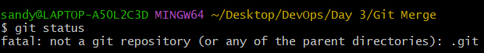

**1.2** **git init** command used to create a git repository in our local repository.



**1.3** We have created a new **sum() function** in **calc.c**

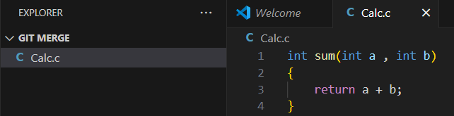

**1.4** We have created one code file in VS Code and saved it and we are checking for the status of git repo by using **git status** command

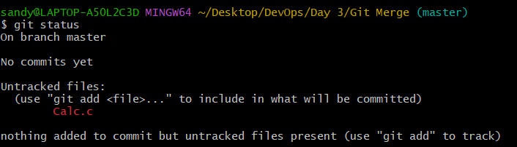

**1.5** Moving calc.c file from **working area to staging** **area**



**1.6** Moving calc.c file from **staging area to commit** **area**

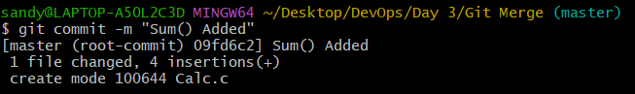

**1.7** We have created another function **diff()** in **calc.c** file, post adding diff() in calc.c file will move from **working area to staging** **area**



**1.8** We have created a new **dif() function** in **calc.c**

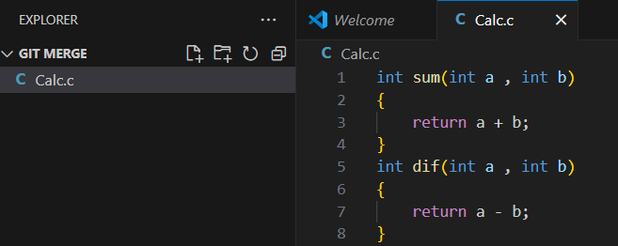

**1.9** Moving calc.c file from **staging area to commit** **area**

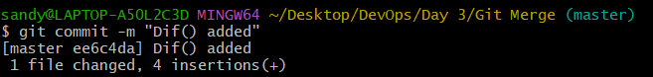

**1.10** Checking Head status of Calc.c file in master branch using git command

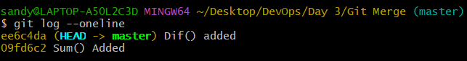

**1.11** Creating new branch using **git branch** command



**1.12** **git branch** command used to check how branches are available for current repo, (*[Asterisk] => used to point where current branch is residing)

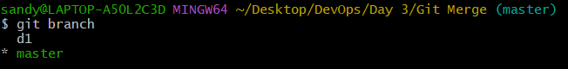

**1.13 git checkout** command used to checkout from current branch to current branch we have mentioned

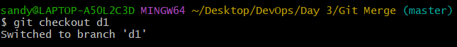

**1.14** In Calc.c we have added **Mul()** in **d1 branch**

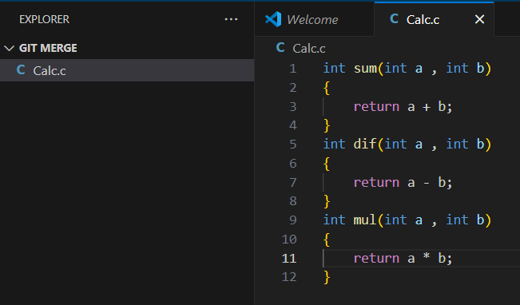

**1.15** We have added mul() VS Code calc.c file and saved it and we are checking for the status of git repo by using **git status** command in d1 branch

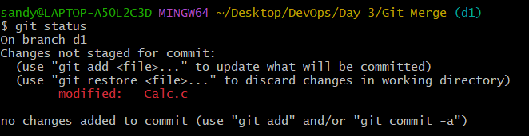

**1.16** Moving calc.c file from **working area to staging** **area into d1 branch**



**1.17** Moving calc.c file from **staging area to commit** **area into d1 branch**

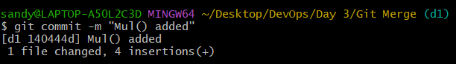

**1.18** Below is reference for master branch after **adding mul()** in d1 branch we won’t see mul() in master because we didn’t created it in master branch.

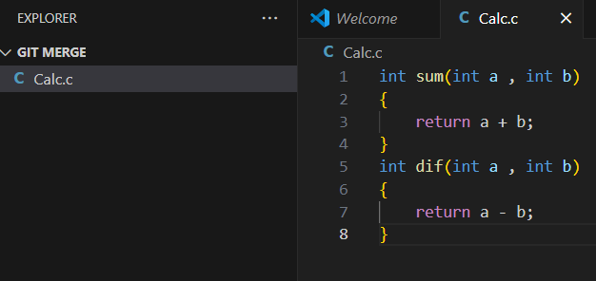

**1.19** We have added **div()** in master branch using VS code.

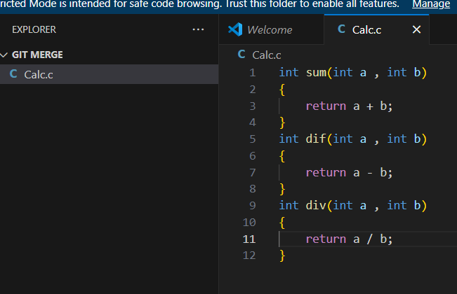

**1.20** We have added div() VS Code calc.c file and saved it and we are checking for the status of git repo by using **git status** command in **Master** branch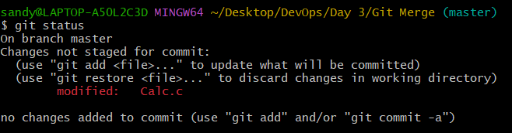

**1.21** Moving calc.c file from **working area to staging** **area into master branch**



**1.22** Moving calc.c file from **staging area to commit** **area into master branch**

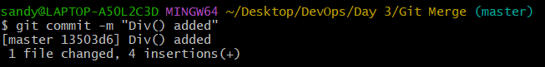

**1.23** Checking Head status of Calc.c file in master branch using git command

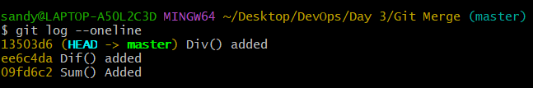

**1.24** Checking Head status of Calc.c file in d1 branch using git command

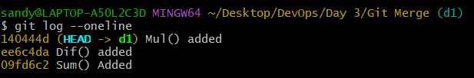

**1.25** Created an empty file using touch command in Git Local Repository in d1 branch (touch d2.txt => used to create empty file in our local Git repo)



**1.26** We have added d2.txt empty text file created and we are checking for the status of git repo by using **git status** command in **d1** branch

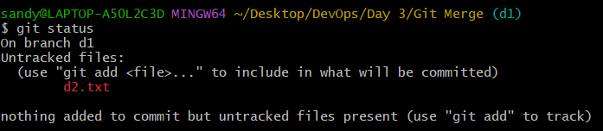

**1.27** We have added d2.txt empty text file created and below is screenshot for availability in git local repo in **d1** branch

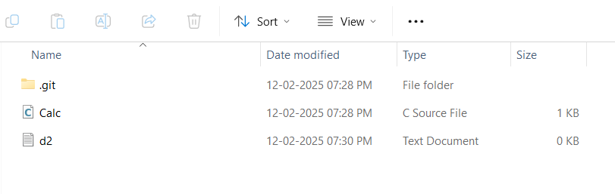

**1.28** Moving d2.txt empty text file from **staging area to commit** **area into d1 branch**

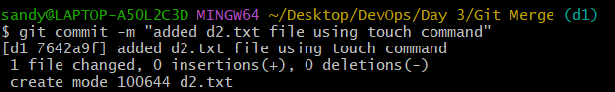

**1.29** Below is screenshot for availability of files details in git local repo in **Master** branch

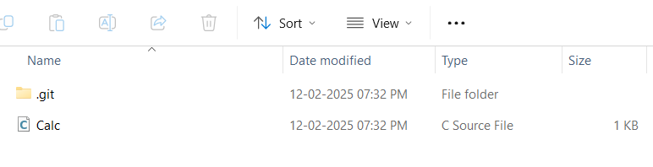

**1.30** Created an empty file using touch command in Git Local Repository in master branch (touch d1.txt => used to create empty file in our local Git repo)



**1.31** Below is screenshot for availability of files details in git local repo in **Master** branch after adding d1.txt text file

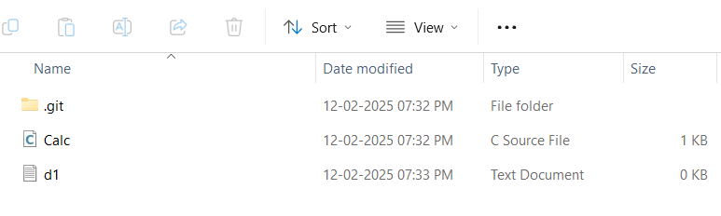

**1.32** We have added d1.txt empty text file created and we are checking for the status of git repo by using **git status** command in **master** branch 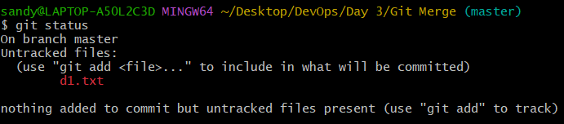

**1.33** Moving d1.txt empty text file from **staging area to commit** **area into master branch**

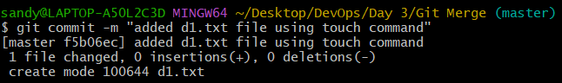

**1.34** Checking **Head status** of **Calc.c file and d1.txt file** in **master branch** using git command

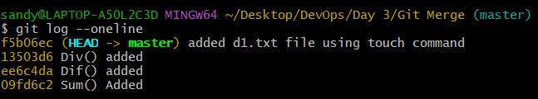

**1.35** Checking **Head status** of **Calc.c and d2.txt file** in **d1 branch** using git command

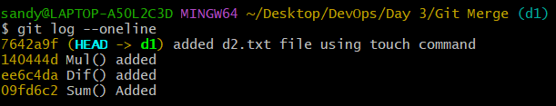

**1.36** Now we are trying to create merge code from **d1 branch to master branch** using git command now we could see we are having **merge conflict is happening because of content of calc.c file isn’t matching with both branch file** for **Mul() and Div()** function.

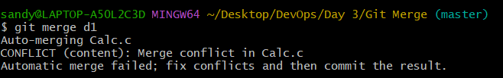

**1.37** Below we could see option to overcome **merge conflict** **where we need to resolve manual way** as mentioned below.

**i. Accept Current Change, ii. Accept Incoming Change, iii. Accept Both Changes and iv. Compare Changes.**

Below reference is shown by using VS Code,

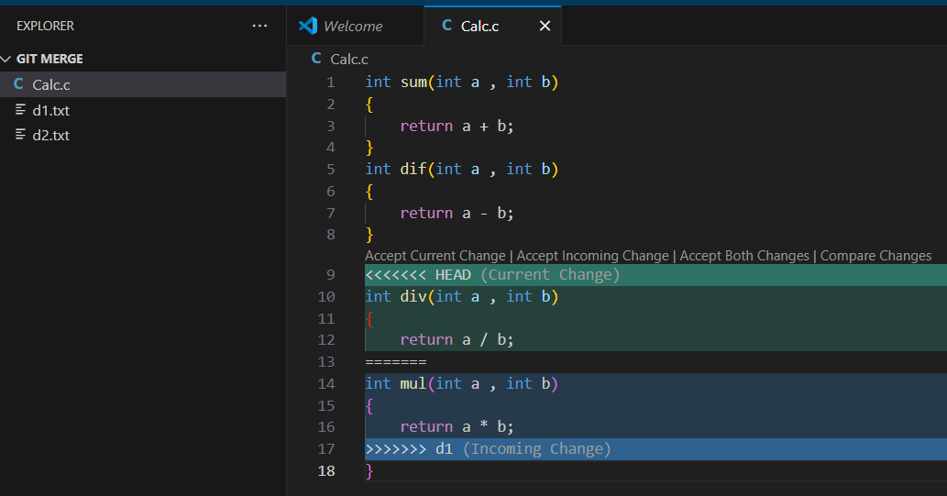

**1.38** **i. Accepting** **Current Change** below is example for selecting Accepting Current Change below we could only dif() is coming and it omitting mul() function since it been added on d1 branch

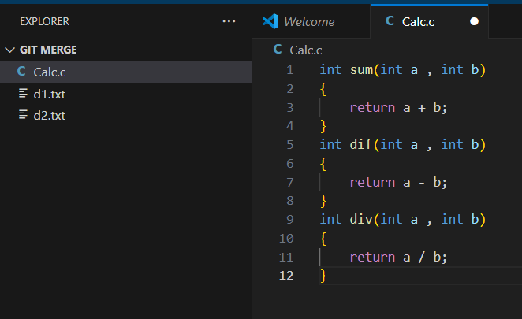

**1.39** **ii. Accept Incoming Change** below is example for selecting Accepting Incoming Change below we could only mul() is coming and it omitting dif() function since it been added on master branch

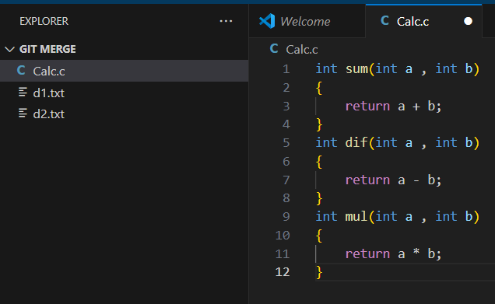

**1.40** **iii. Accept Both Changes** below is example for selecting Accepting BothChange below we could see mul() and dif() function will come it will add on master branch as well.

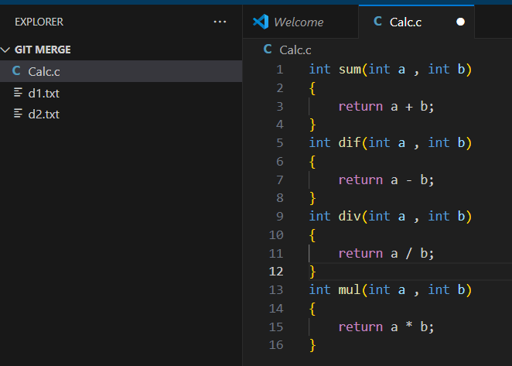

**1.41 iv. Compare Changes** below is example for selecting CompareChange below we could see mul() and dif() function will come we can add to master branch based on our manual intervention what we are in need of.

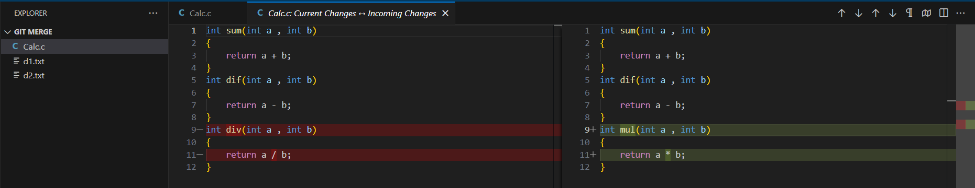

**1.42** After selecting merge option we are checking on the status of master branch merging status

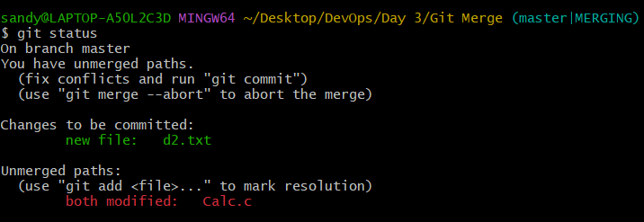

**1.43** Moving **d2.txt empty text file and mul() in calc.c file** from d1 branch moving it to **staging area to commit** **area into master branch**



**1.44** Checking final log detail in master branch

